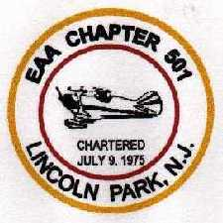
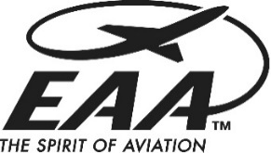


EAA Chapter 501
Lincoln Park, NJ
$10,000 Mike Dzurny Flight Training Scholarship

Long time EAA Chapter 501 member Mike Dzurny has generously funded an annual $10,000 flight training scholarship. It is Mike’s goal to provide financial assistance to someone who is passionate about learning to fly or obtaining an advanced rating or license.
Final award will be based on which license or rating the applicant is pursuing:
- Maximum of $10,000 for Private, Commercial, or ATP.
- Maximum of $10,000 for the Instrument Rating.
- Maximum of $5,000 for any other rating or endorsement.
ELIGIBILITY REQUIREMENTS:
- Funds may be used for any license or rating.
- The applicant must be 18 years old or older.
- The applicant must possess at least a Third-Class FAA Medical Certificate (not Basic Med).
- The applicant must NOT be a high school student.
- The scholarship is only for flight training costs and related expenses, including the cost of a successful check ride, at an FAA approved flight school chosen by the applicant.
- The chosen flight school must be in northern New Jersey or southern New York.
- The successful applicant must pass the written exam for the license or rating sought within 3 months of scholarship award. Scholarship payments will be suspended if this does not occur.
- Applicant must be a U.S. citizen or show proof of being a legal resident of the U.S.
- The scholarship is NOT to be used for tuition payments at colleges or universities.
- EAA Chapter 501 members are eligible, however current members of the Board of Directors and/or the Scholarship Selection Committee ARE NOT eligible.
- Training must begin within 30 days of scholarship award.

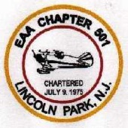
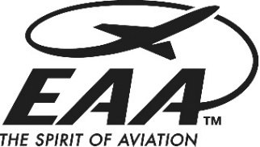
EAA Chapter 501
Lincoln Park, NJ
$10,000 Mike Dzurny Flight Training Scholarship

APPLICATION PROCESS:
- Submission of an application form by FRIDAY OCTOBER 16TH 2026.
- Included with the application will be an essay explaining why the license or rating is being pursued. A statement on relative financial need must be included in the essay (the applicant must disclose any additional funding source for the license or rating being sought).
- A letter of recommendation must be submitted with the application from the applicant’s certified flight instructor or flight school.

SELECTION PROCESS:
- A final decision will be based on a personal interview and strength of the essay.

An application with detailed instructions can be requested from:
scholarship@eaa501.org

